
A 10
Sreenidhi Institute of Science & Technology
(An Autonomous Institution)
Code No: 102CC04
M. TECH. (CAD / CAM) I – Year I – Semester Examinations, March, 2011 (Regular)
SUB : ADVANCED MECHANICS OF SOLIDS.

Time: 3 Hours Max. Marks : 60

Note : No additional answer sheets will be provided.
Assume suitable data where ever necessary.

* * * * *
Part-A (Objective Type) Max.Marks:10

Answer all the QUESTIONS.
1. Calculate the factor 'A_{m}' for the rectangular cross section in a curved beam.
2. Explain shear flow in case of a symmetrical beam.
3. Explain torsion of a rectangular thin walled members.
4. What are the assumptions for finding solution of a contact stress problem.
5. What are the different types of Elastic foundations? Give examples.

Part – B (Subjective Type)
Max.Marks: 50
Answer any Five. All questions carry equal marks.

1. a) Determine the principal moments of inertia for an unequal angle section 200mm X I8O mm X IO mm.
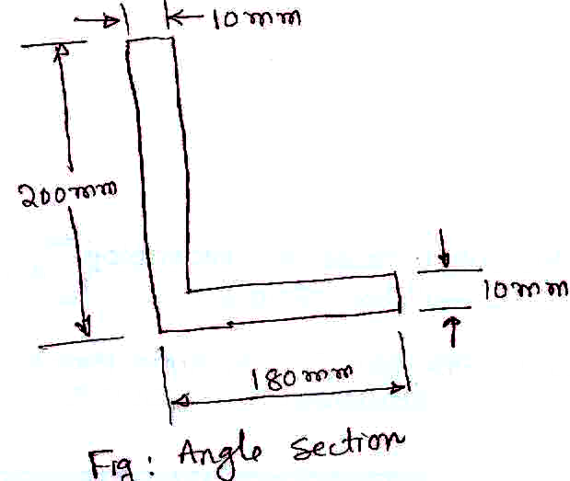
[ 4 ]

b) Explain the Procedure for calculating shear center for a unsymmetrical channel C - section with suitable
dimensions. [ 6 ]
- A closed ring of mean radius of 120 mm is subjected to a pull of 40 kN, the line of action of which passes through its center. The ring is circular in cross section with a radius equal to 40 mm. Find the maximum value of tensile and compressive stress in the ring.
- A 250 mm x 250 mm "L" section with 10 mm thickness is subjected to a torque of 2500N-m. Find the maximum shear stress induced in the section and the angle of twist per unit length. Assume G=E=0.8x 10⁵/N/mm²
- An infinitely long steel beam of unit width and 200 mm thick is resting on an elastic foundation whose modulus of foundation is 10 N/mm². A concentrated load of 8 kN is applied at a point on the beam. Determine the maximum deflection of the beam and the maximum bending stress. Take E=2x 10⁵ N/mm²and v=0.28.
5. a) Obtain an expression for deflection in pure bending of plates in terms of lateral loading. [ 6 ]
b) Write down boundary conditions for different edge conditions for rectangular plates under lateral loading.
[ 4 ]
6. Determine the maximum radial and circumferential stress in a flat steel disc of 600 mm diameter and uniform thickness of 10 mm, rotating at 3000 RPM. Take ρ=7850 kg / m³. ν = 0.3.
7. Two semi circular disks are in contact under the load 6 KN. The radii of curvature before in contact are 130 and 220 mm. The radii of curvature after contact are 60 and 80 mm. Two disks are made of steel having young's modules 200 GPa and poison ratio 0.3. Find maximum principal stress and maximum shear stress.

